2020 Air Quality Annual Status Report (ASR)

In fulfilment of Part IV of the
Environment Act 1995
Local Air Quality Management

July 2020

Local Authority Officer | Amanda Berry
Department | Environmental Health
Address | Thanet District Council Offices, Cecil Street, Margate, Kent CT9 1XZ
Telephone | 01843 577422
E-mail | amanda.berry@thanet.gov.uk
Report Reference number | J3709B/1/F1
Date | July 2020

Executive Summary: Air Quality in Our Area

Air Quality in Thanet
Air pollution is associated with a number of adverse health impacts. It is recognised as a contributing factor in the onset of heart disease and cancer. Additionally, air pollution particularly affects the most vulnerable in society: children and older people, and those with heart and lung conditions. There is also often a strong correlation with equalities issues because areas with poor air quality are also often the less affluent areas,. Consequently, improving air quality will support a reduction in health inequalities.
The Public Health Outcomes Framework is a Department of Health data tool for England, intended to focus public health action on increasing healthy life expectancy and reducing differences in life expectancy between communities. The PHOF includes an indicator, based on the effect of particulate matter (PM_{2.5}) on mortality. For Thanet, the fraction of mortality attributable to particulate air pollution was 5.5%, which compares to an average value of 5.6% for the region and an average of 5.2% for England.
The annual health cost to society of the impacts of particulate matter alone in the UK is estimated to be around £16 billion.
The Local Air Quality Management (LAQM) system, as set out in Part IV of the Environment Act 1995, places an obligation on all local authorities to regularly review and assess air quality in their areas, and to determine whether or not the air quality objectives are likely to be achieved. Where exceedances are considered likely, the local authority must declare an Air Quality Management Area (AQMA) and prepare an Action Plan setting out the measures it intends to put in place in pursuit of the objectives.
The district of Thanet is located on the eastern side of Kent, in the south-east of England. It has a combination of coastal, urban and rural environments and includes the main towns of Margate, Ramsgate and Broadstairs. It is a popular holiday and day trip destination and, as a result, sees the number of vehicle movements grow considerably in the summer months. There is also a working port at Ramsgate.
The main source of air pollution in the district is traffic emissions from major roads, notably the A28, A299, A254, A255 and A256. An Air Quality Management Area (AQMA) was declared in March 2006 for The Square, Birchington, where exceedances of the annual mean objective for nitrogen dioxide (NO₂) were predicted.
A second AQMA was declared at High Street, St Lawrence in April 2010. These two AQMAs were combined into a single Thanet Urban AQMA in 2011 (see https://uk-air.defra.gov.uk/aqma/details?aqma_ref=1514 for details).
Results from continuous sites for 2019 indicate that the annual mean objective and the 1-hour mean objective for nitrogen dioxide were met at both monitoring locations and there were no exceedances of the annual mean and 24-hour mean PM₁₀ objectives at either monitoring location.
The diffution tube results also show that the objectives are achieved at all sites within the AQMA for the second year in succession. It is therefore proposed that the AQMA is revoked following a review of the 2020 monitoring data. Thanet District Council collaborates with other local authorities across Kent through the Kent and Medway Air Quality Partnership. The partnership manages the Kent and Medway Air Quality Monitoring Network, promotes improvement of air quality within the region and prepares Kent wide guidance (such as on planning and air quality). More information can be found at http://www.kentair.org.uk/.

Actions to Improve Air Quality
Thanet District Council has prepared an Air Quality Action Plan (AQAP) to address the Thanet Urban Air Quality Management Area (AQMA), where air quality fails to meet required standards. Policies and actions were subsequently identified and divided into the following broad subjects, based on the area and type of effects that may be achieved:
- Partnership between Thanet District Council and the Local Transport Authority (Kent County Council) - Kent County Council is responsible for overall transport strategy. As the AQMA in Thanet is dominated by emissions from transport, a partnership arrangement between the District and County Councils for the development of the Action Plan was used. Kent County Council has proposed actions, which they themselves can implement in pursuit of the air quality objectives. The Thanet Transport Strategy (currently in draft format) contains a proposal to have an inner circuit in Birchington, effectively bypassing The Square, which is the site of the longest standing AQMA;
- Thanet District Council, as part of the Kent and Medway Air Quality Partnership, has been working with KCC on the development of the Kent and Medway Energy and Low Emissions Strategy. Its purpose is to identify an evidence-based approach to deliver clean growth. This includes strategies and actions to reduce carbon emissions, eliminate poor air quality, reduce fuel poverty and deliver an affordable, clean and secure energy supply. The Kent and Medway Energy and Low Emissions Strategy has been consulted on and may be viewed at https://consultations.kent.gov.uk/consult.ti/energyandlowemissionconsultation/consultationHome. The final strategy was expected to be published in Spring 2020.
- Partnership with Development Planning - Planning is an effective tool to improve air quality. It can be used to locate development to reduce emissions overall, and reduce the direct impacts of new development, through policy requirements. Air Quality Technical Planning Guidance was produced by Thanet District Council in August 2016. The Local Plan also provides policies in relation to new development and air quality;
- Thanet District Council is proposing to phase out older diesel cars in the draft Hackney Carriage and Private Hire Licensing Policy 2020 – 2023, however this change has been delayed due to the current COVID-19 situation; and
- The Council continue to work with Kent County Council on a successful application for DfT funding for ULEV taxis (2018-2020).
In addition to the Action Plan, Thanet District Council declared a climate change emergency, in July 2019, and has developed a Members Working Group with the aim of producing a Climate Change Emergency Action Plan. This is likely to yield co-benefits with air quality once actions are implemented.

Conclusions and Priorities
Monitoring in 2019 showed that there were no exceedances of the AQS objectives. There are, however, still health effects of air pollution below the objective levels. Road transport is the dominant source of pollution within Thanet’s AQMA, and reducing road traffic emissions within the AQMA and across Thanet therefore remains the key air quality priority. This will also contribute to reducing PM_{2.5} concentrations across the district, which has the greatest health effects.

Local Engagement and How to get Involved
As the main source of air pollution within Thanet is road transport emissions, the easiest way for the public to get involved with helping improving air quality in the District would be to find alternatives to travelling by private vehicle. The following are suggested alternatives to private travel that would contribute to improving air quality within the District:
- Use public transport where available – this reduces the number of private vehicles in operation, which will in turn reduce congestion, both of which will help to reduce pollutant concentrations;
- Walk or cycle if your journey allows –choosing to walk or cycle for your journey will reduce the number of private vehicles on the roads, and there is the added benefit of keeping fit and healthy. In addition, many of the cycle routes and footpaths are off-road, meaning you will not be exposed to the higher concentrations that occur close to roads;
- Car/lift sharing – Where a number of individuals are making similar journeys, such as travelling to work or to school, car sharing reduces the number of vehicles on the road and therefore reduces congestion and overall emissions. Car sharing can be promoted via travel plans through the workplace and within schools; and
- Alternatively fuelled / more efficient vehicles – Fully electric, hybrid and more fuel efficient cars are available and have different levels of benefits by reducing emissions. Locations of publicly available electric vehicle charging points in Thanet and nearby, are available at: www.evsoutheast.net/
Table of Contents
Executive Summary: Air Quality in Our Area 1
Air Quality in Thanet 1
Actions to Improve Air Quality 2
Conclusions and Priorities 4
Local Engagement and How to get Involved 4
1 Local Air Quality Management 6
2 Actions to Improve Air Quality 7
2.1 Air Quality Management Areas 7
2.2 Progress and Impact of Measures to address Air Quality in Thanet District Council 9
2.3 PM_{2.5} – Local Authority Approach to Reducing Emissions and/or Concentrations 14
3 Air Quality Monitoring Data and Comparison with Air Quality Objectives and National Compliance 17
3.1 Summary of Monitoring Undertaken 17
3.1.1 Automatic Monitoring Sites 17
3.1.2 Non-Automatic Monitoring Sites 17
3.2 Individual Pollutants 18
3.2.1 Nitrogen Dioxide (NO₂) 18
3.2.2 Particulate Matter (PM₁₀) 19
Appendix A: Monitoring Results 20
Appendix B: Full Monthly Diffusion Tube Results for 2019 35
Appendix C: Supporting Technical Information / Air Quality Monitoring Data QA/QC 38
Appendix D: Maps of Monitoring Locations and AQMAs 45
Appendix E: Summary of Air Quality Objectives in England 55
Glossary of Terms 56
References 57

Local Air Quality Management
This report provides an overview of air quality in Thanet in 2019. It fulfils the requirements of Local Air Quality Management (LAQM) as set out in Part IV of the Environment Act (1995) and the relevant Policy and Technical Guidance documents.
The LAQM process places an obligation on all local authorities to regularly review and assess air quality in their areas, and to determine whether or not the air quality objectives are likely to be achieved. Where an exceedance is considered likely the local authority must declare an Air Quality Management Area (AQMA) and prepare an Air Quality Action Plan (AQAP) setting out the measures it intends to put in place in pursuit of the objectives. This Annual Status Report (ASR) is an annual requirement showing the strategies employed by Thanet District Council to improve air quality and progress that has been made.
The statutory air quality objectives applicable to LAQM in England can be found in Table E.1 in Appendix E.

Actions to Improve Air Quality

Air Quality Management Areas
Air Quality Management Areas (AQMAs) are declared where there is an exceedance or likely exceedance of an air quality objective. After declaration, the authority must prepare an Air Quality Action Plan (AQAP) within 12 months, setting out measures it intends to put in place in pursuit of compliance with the objectives.
A description of the AQMA declared by Thanet District Council can be found in Table 2.1. Further information related to declared or revoked AQMAs, including maps of AQMA boundaries are available online at https://uk-air.defra.gov.uk/aqma/local-authorities?la_id=280. Appendix D: Maps of Monitoring Locations and AQMAs provides maps of air quality monitoring locations in relation to the AQMA.

Table 2.1 – Declared Air Quality Management Area
AQMA Name | Date of Declaration | Pollutants and Air Quality Objectives | City / Town | One Line Description | Is air quality in the AQMA influenced by roads controlled by Highways England? | Level of Exceedance (maximum monitored/modelled concentration at a location of relevant exposure) |  |  |  | Action Plan
 |  |  |  |  |  | At Declaration |  | Now |  | Name | Date of Publication |  | Link
Thanet Urban AQMA | 17/11/2011 | NO₂ Annual Mean | Thanet | An area encompassing a number of urban areas within Thanet | No | 47 | µg/m³ | 37.6 | µg/m³ | Air Quality Action Plan |  | 2013 |  | https://democracy.thanet.gov.uk/documents/s30405/Annex%201%20-%20Thanet%20AQAP%202013%20v2.pdf

☒ Thanet District Council confirm the information on UK-Air regarding their AQMA(s) is up to date

Progress and Impact of Measures to address Air Quality in Thanet District Council
Defra’s appraisal of the 2019 ASR confirmed that the conclusions were acceptable for all sources and pollutants, and it was noted that there were no exceedances of the nitrogen dioxide annual mean objective within Thanet. With regards to the AQMA, Defra supports the Council’s decision to review monitoring data in the AQMA, and to assess whether the AQMA should reduce in size or be revoked. Defra acknowledged that the measures within the AQAP have been updated; however, they encouraged the Council to produce a new AQAP since the current version was published over five years ago. In light of the reductions in concentrations, and absence of any exceedances, the AQAP will not be updated, but measures will be progressed through other policy areas such as the Kent Low Emissions Strategy, the Thanet Transport Strategy and the planning system. These documents will also be used to progress reductions in PM_{2.5} concentrations across Thanet. All other minor comments made by Defra have been taken into account in this (2020) ASR.
Details of all the Action Plan measures completed, in progress or planned, are set out in Table 2.2 including those that supersede the AQAP. More detail on these measures can be found in the Action Plan. The key completed measures are a successful ULEV bid for electric charging infrastructure for taxis and the Kent and Medway Energy and Low Emissions Strategy.
Thanet District Council expects the new charging points and accompanying Taxi Licensing Policy, which will introduce an age limit on diesel vehicles, as well as the publication of Kent and Medway Energy and Low Emission Strategy, to be completed in 2020. Many of the other measures require ongoing work. Thanet District Council’s priorities for the coming year are:
- Continue the partnership with Kent County Council on the implementation of the Local Transport Plan;
- Support the development of the draft Thanet Transport Strategy which has been prepared to identify a framework of transport policies to support the growth identified in the draft Thanet Local Plan;
- Continue to engage with land-use and transport planners to ensure the actions are supported by all parts of the authority;
- Continue to raise awareness of air quality issues within the District;
- Continue to work with Kent County Council to undertake identified feasibility studies of measures to tackle air pollution, to determine more robustly the effectiveness and cost of options; and
- Encourage the public to use sustainable transportation including public transport, car sharing, cycling and walking.
The principal challenges and barriers to implementation that Thanet District Council faces is a lack of resources.
Whilst the measures set out above and in Table 2.2 will help to contribute towards a reduction in concentrations, Thanet District Council anticipates that further additional measures are likely to be implemented through the Kent Local Transport Plan and the Thanet Transport Strategy. Particularly as the latter is adopted, air quality will be a key consideration in measures implemented.

Table 2.2 – Progress on Measures to Improve Air Quality
Measure No. | Measure | EU Category | EU Classification | Organisations involved and Funding Source | Planning Phase | Implementation Phase | Key Performance Indicator | Reduction in Pollutant / Emission from Measure | Progress to Date | Estimated / Actual Completion Date | Comments / Barriers to implementation
1 | Air Quality Guidance | Policy Guidance and Development Control | Air Quality Planning and Policy Guidance | TDC | 2015/2016 | On-going | - | - | Completed in August 2016 | August 2016 | . All development in urban AQMA >10units is required to have EV charge points and low NOx boilers.  All major dev is required to fund emissions offsetting measures.
2 | Energy and Low Emissions Strategy | Policy Guidance and Development Control |  | Kent and Medway | 2018/2019 | Consultation | - | - | Currently out for consultation | September 2019 | Identifies an evidence-based approach to deliver clean growth.
3 | Investigate Traffic Signal and Junction Configuration to improve traffic flows | Traffic Management | UTC, Congestion management, traffic reduction | KCC /TDC | 2011/12 | Urban wide area  On-going | Peak queue lengths | - | On-going |  | Measure update with KCC. New inner circuit has been proposed within the Transport Plan.
4 | Improving Movement of Freight | Vehicle Fleet Efficiency | Driver training and ECO driving aids | KCC /TDC | 2011/12 | 2012-2013 | % HGV on roads through AQMA | 2% | On-going | - | TDC local Plan Policy TP08 – Freight and Service Delivery seeks to adequate off-street parking for freight to encourage a smoother flow of traffic.
5 | Encouragement of Public Transport | Transport Planning and Infrastructure | Public transport improvements-interchanges stations and services | KCC /TDC/QBP | 2012 | 2012-2015 | Number of Euro IV or above buses, bus patronage, number of bus infrastructure improvement projects | 5% | On-going | - | Stagecoach Thanet has invested £4million on 24 new buses to operate on the ‘Thanet Loop’ service. The bio-diesel single deckers are equipped with ‘Euro 6’ engines. TDC local Plan Section 18 contain several transport policies which seek to encourage public transport.
6 | Car Sharing and Travel Planning | Promoting Travel Alternatives | Workplace Travel Planning | KCC /TDC | 2011/12 | 2012-2013 | Number of registered users of scheme or travel plan | 2% | On-going | - | TDC local Plan Policy SP41 – safe and Sustainable Travel and SP43 – Transport Infrastructure.
7 | Promotion of Cycling and Walking Measures | Promoting Travel Alternatives | Promotion of cycling | KCC /TDC | 2011/12 | 2012 | Number of cyclists/walkers | 1% | On-going | - | TDC local Plan Policy TP02 – walking and TP03 Cycling policies specifically encourage these measures.
8 | Promotion of air quality issues | Public Information | Via the Internet | TDC | 2011/12 | 2012 | Number of press releases, reports on website | - | On-going | - | Ongoing.  Promoted National Clean Air Day via website.  K&MAQP now have communication sub group develop to raise AQ public information.
9 | Parking Enforcement | Traffic Management | Workplace Parking Levy, Parking Enforcement on highway | TDC | 2012 | 2013 | Number of Penalty Charge Notices served | - | On-going | - | TDC Parking Policy available at https://www.thanet.gov.uk//wp-content/uploads/2018/03/Parking-Policy-2015-20.pdf–
10 | OLEV funding application | Promoting Low Emission Transport | Other | KCC / TDC | 2014 | 2015 | Number of charge connections | - | Completed March 2015 | - | 4 Charging points installed and operational as of March 2015
11 | Phasing out older diesel taxis Taxi Licensing Policy | Promoting Low Emission Transport | Taxi Licensing Conditions | TDC | 2018 | 2019-2022 | Number of licensed diesel vehicles | - | On-going | - | Unforeseen delays with draft licensing policy given staffing issues and Covid pandemic
12 | ULEV funding application EV charging points for taxis | Promoting Low Emission Transport | Taxi Emission Incentives | KCC / TDC | 2018 | 2019 | Number of chargers installed | - | Complete  March 2020 | - | Successful bid. 4 charging points installed summer 2020
13 | Thanet Transport Strategy | Transport Planning and Infrastructure | Other | KCC/TDC | 2018 | 2015-2031 | Inner Circuit Road, Thanet Parkway station | - | Draft Thanet Transport Strategy | - | Draft Transport Strategy to accompany the Local Plan which is now at examination stage. The proposed inner circuit will alleviate a number of congested pinch points on existing road network.
14 | Ensure that all TDC EV Points are maintained and available for the public | Promoting Low Emission Transport | Other | TDC | 2017 | 2017 | Number of charges | - | Ongoing | -
Note: TDC = Thanet District Council; KCC = Kent County Council; UTC = Urban Traffic Control
Measures underway or completed not in AQAP

PM_{2.5} – Local Authority Approach to Reducing Emissions and/or Concentrations
As detailed in Policy Guidance LAQM.PG16 (Chapter 7), local authorities are expected to work towards reducing emissions and/or concentrations of PM_{2.5} (particulate matter with an aerodynamic diameter of 2.5µm or less). There is clear evidence that PM_{2.5} has a significant effect on human health, including premature mortality, allergic reactions, and cardiovascular diseases.
Thanet District Council does not currently undertake any monitoring of PM_{2.5}. There are currently no specific measures in place to address PM_{2.5} concentrations within the District. However, Thanet District Council’s existing Air Quality Action Plan, as well as other policy areas such as the Kent Low Emissions Strategy, the Thanet Transport Strategy and controls within the planning system, will help to reduce local PM_{2.5} emissions.
Thanet District Council is part of the Kent Health and Wellbeing Board, which brings together County and District Councillors, senior officers from the NHS Area Team, Clinical Commissioning Groups, Social Care and Public and members of the Local Healthwatch. The board produced the Kent Joint Health and Wellbeing Strategy, which sets out how the multidisciplinary teams can align their plans to improve public health and tackle key health issues over the coming years.
Thanet District Council is working with Public Health colleagues to prioritise action on air quality to help reduce the health burden from air pollution. The Public Health Outcomes Framework (PHOF) is a Department of Health data tool for England, intended to focus public health action on increasing healthy life expectancy and reducing differences in life expectancy between communities. The PHOF includes an indicator, based on the effect of exposure to particulate matter (PM_{2.5}) on mortality. For Thanet, the fraction of mortality attributable to PM_{2.5} is 5.5%, which compares to an average value of 5.6% for the region and an average of 5.2% for England. The approach used in partnership with Public Health colleagues includes the encouragement of active travel, which will also have wider public health benefits captured in other indicators such as increased physical activity (indicator 2.13) and reducing excess weight at various ages (indicators 2.6 & 2.12).
The Local Transport Plan for Kent sets out a 20-year transport delivery plan for the County and includes strategies to improve the transport infrastructure to support future growth, and specifically targets AQMAs and congestion hotspots for improvements. These transport improvements are expected to reduce PM_{2.5} emissions, especially within the AQMAs where health is of key concern, but also on a wider basis. The draft Thanet Transport Strategy includes a high-level appraisal of the transport network and addresses the local and wider transport and infrastructure implications arising from associated development sites with options being tested. It identifies strategic transport issues, key infrastructure requirements, and specific transport improvement and initiatives, whilst taking account of relevant policy at both a local and national level.
Thanet District Council is part of the Kent and Medway Air Quality Partnership (K&MAQP), which aims to deliver a consistent approach to tackling air pollution across the County, sharing knowledge and information between Kent County Council, district councils, health authorities, Highways England, the Environment Agency, Public Health England and various consultants and research partners. The Kent and Medway Air Quality Monitoring Network (K&MAQMN) includes a number of sites monitoring pollution (including PM_{2.5}) across the County. Data for the network is reported through a dedicated website, KentAir, which can be found at www.kentair.org.uk. Thanet District Council has been working with members of K&MAQP and KCC on the production of a Kent and Medway Low Emissions Strategy/Action Plan.
The planning regime is also important for reducing concentrations of PM_{2.5} and Thanet District Council is focused through its planning policy on preventing particulate matter concentrations being inadvertently increased. Thanet District Council submitted its draft Local Plan to 2031 on 30th October 2018 and received the Inspectors report in early April 2020. The Local Plan includes the updated Air Quality Policy which states that:
Policy SE05 - Air Quality
All major development schemes should promote a shift to the use of sustainable low emission transport to minimise the impact of vehicle emissions on air quality, Development will be located where it is accessible to support the use of public transport, walking and cycling.
New development must ensure that users are not significantly adversely affected by the air quality and include mitigation measures where appropriate.
All developments which either individually or cumulatively are likely to have a detrimental impact on air quality, will be required to submit an Air Quality and/or Emissions Mitigation Assessment, in line with the Air Quality Technical Planning Guidance 2016 and any subsequent revisions.
The Air Quality Assessment should address the cumulative effect of further emissions.
The Emission Mitigation Assessment should address any proposed mitigation measures through good design and offsetting measures that would prevent the National Air Quality Objectives being exceeded or reduce the extent of the air quality deterioration. These will be of particular importance within the urban AQMA, associated areas and areas of lower air quality.
Proposals that fail to demonstrate these will not be permitted.

Air Quality Monitoring Data and Comparison with Air Quality Objectives and National Compliance

Summary of Monitoring Undertaken

Automatic Monitoring Sites
This section sets out what monitoring has taken place and how it compares with the air quality objectives.
Thanet District Council undertook automatic (continuous) monitoring at two sites during 2019. Table A.1 in Appendix A shows the details of the sites.
Maps showing the location of the monitoring sites are provided in Appendix D. Further details on how the monitors are calibrated and how the data have been adjusted are included in Appendix C.

Non-Automatic Monitoring Sites
Thanet District Council undertook non-automatic (passive) monitoring of NO₂ at 34 sites during 2019, an increase from 32 in 2018. Two of the duplicate tubes at Kentmere Ave were redeployed to Margate Road Ramsgate and Boundary Road Ramsgate to expand the number of monitoring sites. Table A.2 in Appendix A shows the details of the sites.
Maps showing the location of the monitoring sites are provided in Appendix D. Further details on Quality Assurance/Quality Control (QA/QC) for the diffusion tubes, including bias adjustments and any other adjustments applied (e.g. “annualisation” and/or distance correction), are included in Appendix C.
There were five triplicate sites in 2019, these were:
- TH13/46/47 – The Square Birchington
- TH51/52/53 – Boundary Road, Ramsgate (Co-located with ZH4)
- TH54/64/65 – High Street St Lawrence, Ramsgate
- TH67/68/69 – 20 Hereson Road, Ramsgate
- TH70/71/72 – 9 High Street, St Lawrence
Triplicate co-located NO₂ diffusion rubes are installed at ZH4 Thanet Ramsgate (Boundary Road, Ramsgate) automatic monitoring site.

Individual Pollutants
The air quality monitoring results presented in this section are, where relevant, adjusted for bias, “annualisation” and distance correction. Further details on adjustments are provided in Appendix C.

Nitrogen Dioxide (NO₂)
Table A.3 in Appendix A compares the ratified and adjusted measured NO₂ annual mean concentrations for the past five years with the air quality objective of 40µg/m³.
For diffusion tubes, the full 2019 dataset of monthly mean values is provided in Appendix B. Data capture was below 75% for diffusion tube sites TH32 and TH81 (58.3% and 66.7%, respectively), therefore an annualisation adjustment was applied.
Table A.4 in Appendix A compares the ratified continuously monitored NO₂ hourly mean concentrations for the past five years with the air quality objective of 200µg/m³, not to be exceeded more than 18 times per year.
Automatic monitoring results indicate that both the annual mean objective and 1-hour mean objectives continued to be met at both monitoring locations in 2019.
The diffution tube results also show that the objectives are being achieved at all sites within the AQMA for the second year in succession. It is therefore suggested that the AQMA is revoked following a review of 2020 monitoring data. However, Thanet Council’s Local Plan 2031 Policy SP11 sets out a housing requirement over the Plan period of 17,140 dwellings and on the 9th July the Secretary of State approved the Development Consent Order for Manston Airport for freight aircaft upto 10,000 air cargo movements a year, so guidance is sought from Defra as to whether to keep the AQMA as a precautionary approach, or remove it based on monitoring data.
Figure A.1 shows the trend in annual mean NO₂ concentrations at the continuous monitoring locations between 2014 and 2019. Concentrations at Thanet Ramsgate have continued to gradually decline since 2014. Thanet Birchington has also shown a decline in NO₂ concentrations since 2016.
Figure A2 shows the trend in annual mean NO₂ concentrations at the diffusion tube monitoring sites between 2014 and 2019. A downward trend in concentrations is apparent for sites located adjacent to main roads or busy junctions (e.g. TH05, TH10, TH13/46/47, TH70/71/72); for sites further away from the road, such as TH16, TH27, TH31, TH31, TH32 and TH37, a trend in concentrations is not evident. There are no sites exceeding 60µg/m³, which indicates that the 1-hour mean objective is unlikely to be exceeded.

Particulate Matter (PM₁₀)
Table A.5 in Appendix A compares the ratified and adjusted monitored PM₁₀ annual mean concentrations for the past five years with the air quality objective of 40µg/m³.
Table A.6 in Appendix A compares the ratified continuous monitored PM₁₀ daily mean concentrations for the past five years with the air quality objective of 50µg/m³, not to be exceeded more than 35 times per year.
Figure A.1 shows the 2019 results for the annual mean.
The 2019 results show that both annual mean and 24-hour mean objectives were met at both monitoring sites during 2019. The number of days with concentrations above 50µg/m³ in 2019 has shown a decline at ZH4 Thanet Ramsgate, but has increased at ZH5 Thanet Birchington; however, the number of exceedance days is well below the objective level of 35.
Figure A.2 shows the trend in annual mean PM₁₀ concentrations at the two continuous monitoring sites between 2014 and 2019, and Figure A.4 shows the year-on-year numbers of days with concentrations above 50µg/m³. Neither figure shows a clear trend for either site.

Appendix A: Monitoring Results
Table A.1 – Details of Automatic Monitoring Sites
Site ID | Site Name | Site Type | X OS Grid Ref | Y OS Grid Ref | Pollutants Monitored | In AQMA? | Monitoring Technique | Distance to Relevant Exposure (m) | Distance to kerb of nearest road (m) | Inlet Height (m)
ZH4 Thanet Ramsgate | Boundary Road, Ramsgate | Roadside | 638483 | 165430 | NO₂; PM₁₀ | YES | Chemiluminescent; beta attenuation | 16 | 4 | 2
ZH5 Thanet Birchington | The Square, Birchington | Roadside | 630284 | 169052 | NO₂; PM₁₀ | YES | Chemiluminescent; beta attenuation | 4 | 3 | 2

.

Table A.2 – Details of Non-Automatic Monitoring Sites
Site ID | Site Name | Site Type | X OS Grid Ref | Y OS Grid Ref | Pollutants Monitored | In AQMA? | Distance to Relevant Exposure (m) ⁽¹⁾ | Distance to kerb of nearest road (m) ⁽²⁾ | Tube collocated with a Continuous Analyser? | Height (m)
TH05 | The Broadway, Broadstairs | Kerbside | 639020 | 167982 | NO₂ | YES | N | 2.5 | NO | 2.5
TH10 | College Road, Margate | Kerbside | 635539 | 169840 | NO₂ | YES | 0 | 2 | NO | 2.5
TH13/46/47 | The Square, Birchington | Kerbside | 630254 | 169037 | NO₂ | YES | 2 | 1 | NO | 2.5
TH16 | Earlsmede Crescent, Cliffend | Urban Background | 634445 | 164416 | NO₂ | YES | 3 | N/A | NO | 2.5
TH26 | King Street, Ramsgate | Kerbside | 638492 | 165410 | NO₂ | YES | 0 | 3 | NO | 2.5
TH27 | Avebury Avenue, Ramsgate | Urban Background | 639097 | 165971 | NO₂ | YES | 7 | N/A | NO | 2.5
TH31 | High Street, Manston | Urban Background | 634662 | 166026 | NO₂ | NO | 9 | N/A | NO | 2.5
TH32 | Bell-Davies Drive, Minster | Urban Background | 632994 | 166428 | NO₂ | NO | 10 | N/A | NO | 2.5
TH33 | Hill-House Drive, Minster | Urban Background | 631161 | 165486 | NO₂ | NO | 9 | N/A | NO | 2.5
TH34 | Pizza Hut, Westwood Road, Broadstairs | Roadside | 636570 | 167894 | NO₂2 | YES | N | 14 | NO | 2.5
TH36 | Star Lane, Ramsgate Road, Margate | Kerbside | 636405 | 168227 | NO₂ | YES | 0 | 2 | NO | 2.5
TH37 | Kentmere Avenue, Ramsgate | Kerbside | 635932 | 165333 | NO₂ | YES | 10 | N/A | YES | 2.5
TH48 | Canterbury Rd Birchington nr Y | Kerbside | 630419 | 169092 | NO₂ | YES | 1 | 0.5 | YES | 2
TH49 | Kent Gardens, Canterbury Road (A28), Birchington | Roadside | 630186 | 168983 | NO₂ | YES | 3 | 3.5 | NO | 2.5
TH51/52/53 | Boundary Road, Ramsgate | Roadside | 638742 | 165432 | NO₂ | YES | 16 | 4.1 | YES | 2.5
TH54/64/65 | High Street, St. Lawrence | Roadside | 637135 | 165354 | NO₂ | YES | 7 | 1 | NO | 2.5
TH55 | Coxes Lane, Margate Road, Ramsgate | Roadside | 636815 | 167297 | NO₂ | YES | 3 | 10 | NO | 2
TH59 | Church Street, St Peters | Kerbside | 638220 | 168614 | NO₂ | YES | 3 | 2 | NO | 2.5
TH66 | High Street, St. Lawrence, Façade | Roadside | 637112 | 165331 | NO₂ | YES | 0 | 3 | NO | 2.5
TH67/68/69 | 20 Hereson Road, Ramsgate | Roadside | 638536 | 165465 | NO₂ | YES | 0 | 1 | NO | 2.5
TH70/71/72 | 9 High Street, St. Lawrence | Roadside | 637092 | 165340 | NO₂ | YES | 0 | 1 | NO | 2.5
TH76 | Buenos Ayres, Margate | Roadside | 634752 | 170679 | NO₂ | YES | 9.5 | 12 | NO | 2
TH77 | 72 High Street, Minster | Kerbside | 630968 | 164710 | NO₂ | NO | 2.5 | 1 | NO | 1.5
TH78 | Manston Way Walk, Ramsgate | Roadside | 636049 | 167727 | NO₂ | YES | 8 | 2.5 | NO | 2
TH79 | Canterbury Rd, Sarre | Roadside | 625641 | 165002 | NO₂ | NO | 0 | 6.5 | NO | 2.5
TH80 | Newington Rd, Ramsgate | Roadside | 636909 | 165780 | NO₂ | YES | 0 | 1 | NO | 2.5
TH81 | Margate Rd, Ramsgate | Roadside | 637097 | 166799 | NO₂ | YES | 0 | 7.8 | NO | 2.5
TH82 | Westwood Road nr School, Broadstairs | Roadside | 637271 | 167873 | NO₂ | YES | 7 | 7.9 | NO | 2.5
TH83 | Ramsgate Rd (nr car wash) Margate | Roadside | 635907 | 169266 | NO₂ | YES | 0 | 9.5 | NO | 2.5
TH84 | Northdown Rd, Margate | Roadside | 635997 | 171095 | NO₂ | YES | 0 | 6 | NO | 3
TH85 | 143 Boundary Rd, Ramsgate | Roadside | 638026 | 165442 | NO₂ | YES | 0 | 0 | NO | 3
TH86 | 26 Margate Rd, Ramsgate | Roadside | 637747 | 165713 | NO₂ | YES | 2 | 1.5 | NO | 3
Notes:
(1) 0m if the monitoring site is at a location of exposure (e.g. installed on/adjacent to the façade of a residential property).
(2) N/A if not applicable.

Table A.3 – Annual Mean NO₂ Monitoring Results
Site ID | Site Type | Monitoring Type | Valid Data Capture for Monitoring Period (%) ⁽¹⁾ | Valid Data Capture 2019 (%) ⁽²⁾ | NO₂ Annual Mean Concentration (µg/m³) ⁽³⁾
 |  |  |  |  | 2015 | 2016 | 2017 | 2018 | 2019
ZH4 Thanet Ramsgate | Roadside | Automatic | 48.0 | 48.0 | 22.9 | 22.6 | 22.6 | 21.3 | 21.4
ZH5 Thanet Birchington | Roadside | Automatic | 98.8 | 98.8 | 24.6 | 33.6 | 32.4 | 31.0 | 29.3
TH05 | Kerbside | Diffusion Tube | 100.0 | 100.0 | 30.3 | 33.6 | 28.6 | 28.5 | 27.8
TH10 | Kerbside | Diffusion Tube | 100.0 | 100.0 | 34.9 | 35 | 31.0 | 32.3 | 30.7
TH13/46/47 | Kerbside | Diffusion Tube | 100.0 | 100.0 | 42.4 | 44.1 | 40.6 | 37.3 | 35.9
TH16 | Urban Background | Diffusion Tube | 100.0 | 100.0 | 14.7 | 16.7 | 16.4 | 14.4 | 14.9
TH26 | Kerbside | Diffusion Tube | 100.0 | 100.0 | 35.3 | 36 | 33.0 | 32.4 | 30.5
TH27 | Urban Background | Diffusion Tube | 91.7 | 91.7 | 14.1 | 16.3 | 16.4 | 14.2 | 15.1
TH31 | Urban Background | Diffusion Tube | 100.0 | 100.0 | 12.9 | 14.7 | 15.8 | 12.2 | 12.2
TH32 | Urban Background | Diffusion Tube | 58.3 | 58.3 | 14.4 | 15.4 | 16.7 | 14.0 | 14.2
TH33 | Urban Background | Diffusion Tube | 83.3 | 83.3 | 14.9 | 16.5 | 16.1 | 15.0 | 14.6
TH34 | Roadside | Diffusion Tube | 100.0 | 100.0 | 24.1 | 25.8 | 23.7 | 21.8 | 21.7
TH36 | Kerbside | Diffusion Tube | 91.7 | 91.7 | 22.5 | 28.6 | 23.9 | 26.5 | 25.5
TH37 | Kerbside | Diffusion Tube | 75.0 | 75.0 | 14.8 | 16 | 16.1 | 14.4 | 16.3
TH48 | Kerbside | Diffusion Tube | 91.7 | 91.7 | 31.9 | 31.2 | 27.9 | 29.9 | 25.5
TH49 | Roadside | Diffusion Tube | 100.0 | 100.0 | 20.3 | 20.7 | 22.0 | 20.8 | 19.5
TH51/52/53 | Roadside | Diffusion Tube | 100.0 | 100.0 | 23.7 | 23.7 | 21.4 | 20.2 | 19.3
TH54/64/65 | Roadside | Diffusion Tube | 100.0 | 100.0 | 38.2 | 40.9 | 38.0 | 32.7 | 33.7
TH55 | Roadside | Diffusion Tube | 91.7 | 91.7 | 21.9 | 29 | 27.0 | 22.7 | 23.6
TH59 | Kerbside | Diffusion Tube | 91.7 | 91.7 | 29.3 | 33.3 | 31.9 | 28.9 | 28.3
TH66 | Roadside | Diffusion Tube | 100.0 | 100.0 | 31.1 | 27.2 | 26.3 | 24.7 | 24.0
TH67/68/69 | Roadside | Diffusion Tube | 91.7 | 91.7 | 33.7 | 35.6 | 32.2 | 31.8 | 30.4
TH70/71/72 | Roadside | Diffusion Tube | 100.0 | 100.0 | 42.8 | 44.9 | 41.6 | 38.6 | 37.6
TH76 | Roadside | Diffusion Tube | 91.7 | 91.7 | 21.6 | 25.5 | 25.8 | 21.3 | 22.1
TH77 | Kerbside | Diffusion Tube | 100.0 | 100.0 | N/A | N/A | 23.3 | 20.9 | 21.1
TH78 | Roadside | Diffusion Tube | 83.3 | 83.3 | N/A | N/A | 19.9 | 16.9 | 16.8
TH79 | Roadside | Diffusion Tube | 91.7 | 91.7 | N/A | N/A | N/A | 21.4 | 19.6
TH80 | Roadside | Diffusion Tube | 100.0 | 100.0 | N/A | N/A | N/A | 21.0 | 19.1
TH81 | Roadside | Diffusion Tube | 66.7 | 66.7 | N/A | N/A | N/A | 21.2 | 19.1
TH82 | Roadside | Diffusion Tube | 91.7 | 91.7 | N/A | N/A | N/A | 25.1 | 20.8
TH83 | Roadside | Diffusion Tube | 91.7 | 91.7 | N/A | N/A | N/A | 19.4 | 17.2
TH84 | Roadside | Diffusion Tube | 75.0 | 75.0 | N/A | N/A | N/A | 19.1 | 22.1
TH85 | Roadside | Diffusion Tube | 83.3 | 83.3 | N/A | N/A | N/A | 41.8 | 29.2
TH86 | Roadside | Diffusion Tube | 100.0 | 100.0 | N/A | N/A | N/A | 36.7 | 23.4

☒ Diffusion tube data has been bias corrected
☒ Annualisation has been conducted where data capture is <75%

Notes:
Exceedances of the NO₂ annual mean objective of 40µg/m³ are shown in bold.
(1) Data capture for the monitoring period, in cases where monitoring was only carried out for part of the year.
(2) Data capture for the full calendar year (e.g. if monitoring was carried out for 6 months, the maximum data capture for the full calendar year is 50%).
(3) Means for diffusion tubes have been corrected for bias. All means have been “annualised” as per Boxes 7.9 and 7.10 in LAQM.TG16 if valid data capture for the full calendar year is less than 75%. See Appendix C for details.

Figure A.1 – Trends in Annual Mean NO₂ Concentrations
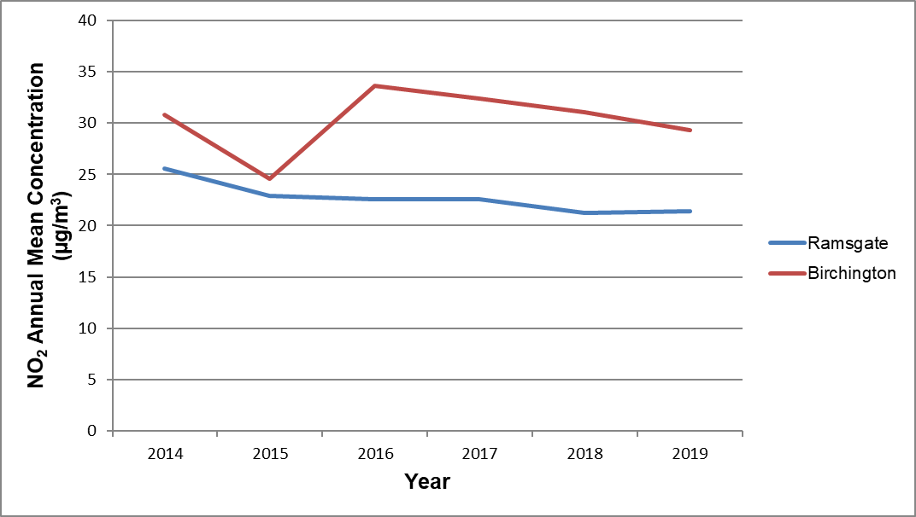
Figure A.2 – Trends in Annual Mean Nitrogen Dioxide Concentrations Measured at Diffusion Tube Monitoring Sites
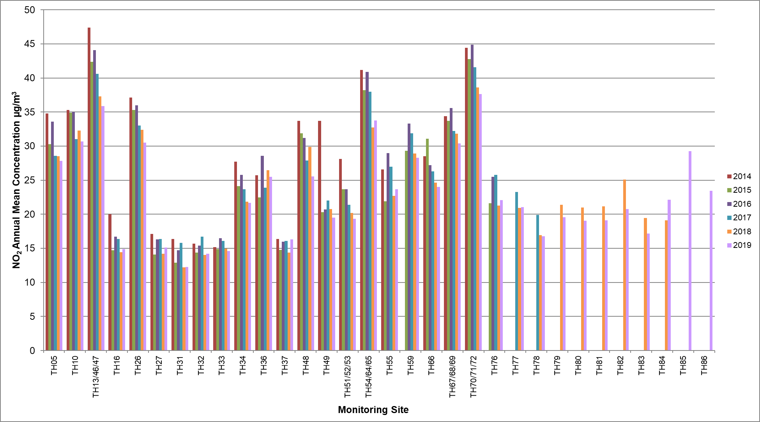
Table A.4 – 1-Hour Mean NO₂ Monitoring Results
Site ID | Site Type | Monitoring Type | Valid Data Capture for Monitoring Period (%) | Valid Data Capture 2019 (%) | NO₂ 1-Hour Means > 200µg/m³
 |  |  |  |  | 2015 | 2016 | 2017 | 2018 | 2019
ZH4 Thanet Ramsgate | Roadside | Automatic | 48.0 | 48.0 | 0 | 0 | 0 | 0 | 0
ZH5 Thanet Birchington | Roadside | Automatic | 98.8 | 98.8 | 0 | 0 | 0 | 0 | 0

Table A.5 – Annual Mean PM₁₀ Monitoring Results
Site ID | Site Type | Valid Data Capture for Monitoring Period (%) | Valid Data Capture 2019 (%) | PM₁₀ Annual Mean Concentration (µg/m³)
 |  |  |  | 2015 | 2016 | 2017 | 2018 | 2019
ZH4 Thanet Ramsgate | Roadside | 34.2 | 34.2 | 24.3 | 25.8 | 24.8 | 24.6 | 22.6
ZH5 Thanet Birchington | Roadside | 94.4 | 94.4 | 22.3 | 24.8 | 23.2 | 25.2 | 23.9

Figure A.3 – Trends in Annual Mean PM₁₀ Concentrations
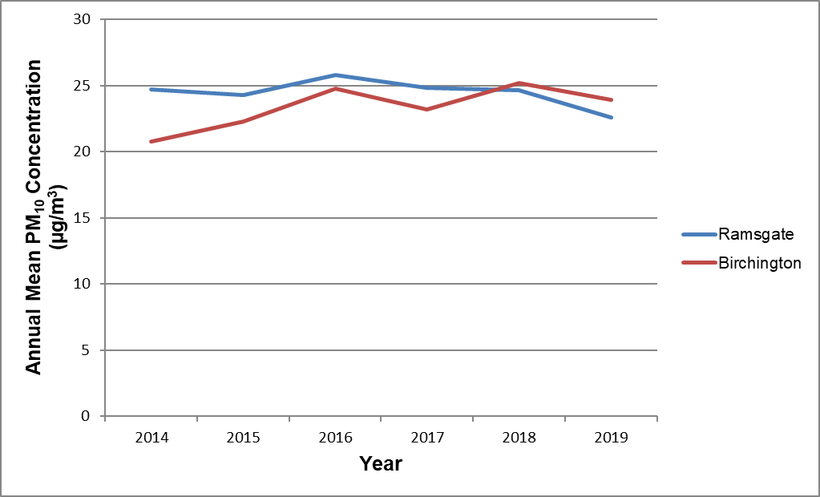
Table A.6 – 24-Hour Mean PM₁₀ Monitoring Results
Site ID | Site Type | Valid Data Capture for Monitoring Period (%) | Valid Data Capture 2019 (%) | PM₁₀ 24-Hour Means > 50µg/m³ ⁽¹⁾
 |  |  |  | 2015 | 2016 | 2017 | 2018 | 2019
ZH4 Thanet Ramsgate | Roadside | 42.3 | 42.3 | 9 | 5 | 13 | 11 | 3(29.3)
ZH5 Thanet Birchington | Roadside | 93.7 | 93.7 | 6 | 4 | 9 | 10 | 14
Notes:
(1) If the period of valid data is less than 85%, the 90.4th percentile of 24-hour means is provided in brackets.

Figure A.4 – Trends in Number of 24-Hour Mean PM₁₀ Results >50µg/m³
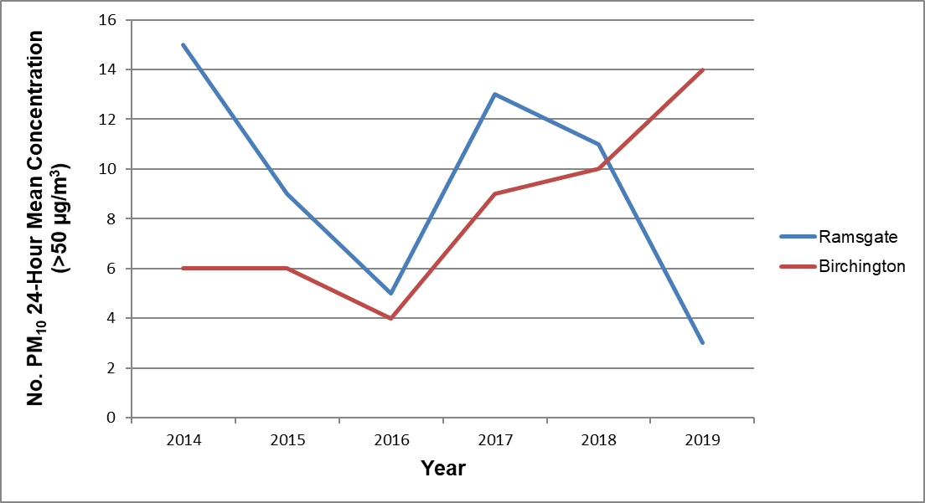

Appendix B: Full Monthly Diffusion Tube Results for 2019
Table B.1 – NO₂ Monthly Diffusion Tube Results – 2019
Site ID | NO₂ Mean Concentrations (µg/m³)
 | Jan | Feb | Mar | Apr | May | Jun | Jul | Aug | Sep | Oct | Nov | Dec | Annual Mean
 |  |  |  |  |  |  |  |  |  |  |  |  | Raw Data | Bias Adjusted (0.75) and Annualised ⁽¹⁾ | Distance Corrected to Nearest Exposure (²)
TH05 | 41.5 | 45.2 | 36.1 | 36.6 | 33.5 | 36.3 | 33.1 | 35.7 | 28.8 | 33.0 | 45.9 | 39.7 | 37.1 | 27.8 | 27.8
TH10 | 33.9 | 47.8 | 38.0 | 53.7 | 39.3 | 41.5 | 37.2 | 39.2 | 32.1 | 36.3 | 50.9 | 40.9 | 40.9 | 30.7 | 30.7
TH13/46/47 | 45.4 | 60.5 | 43.5 | 43.0 | 43.0 | 44.7 | 47.7 | 56.0 | 42.5 | 44.6 | 57.8 | 45.6 | 47.9 | 35.9 | 35.9
TH16 | 28.4 | 28.9 | 21.5 | 23.6 | 16.2 | 15.9 | 13.0 | 16.6 | 13.5 | 15.1 | 24.9 | 21.1 | 19.9 | 14.9 | 14.9
TH26 | 39.6 | 51.9 | 37.1 | 38.3 | 40.3 | 42.8 | 37.1 | 43.7 | 36.1 | 37.2 | 45.8 | 38.6 | 40.7 | 30.5 | 30.5
TH27 | 24.0 | 25.0 | 20.2 | 19.7 | 15.5 | 17.2 | 31.9 | 16.3 | 12.7 | - | 21.2 | 17.7 | 20.1 | 15.1 | 15.1
TH31 | 18.3 | 26.1 | 16.9 | 18.1 | 11.7 | 14.2 | 11.8 | 11.3 | 13.5 | 16.0 | 20.3 | 17.7 | 16.3 | 12.2 | 12.2
TH32 | 22.4 | 30.0 | 17.6 | 22.3 | 15.5 | 14.6 | 12.4 | - | - | - | - | - | 19.3 | 14.2 | 14.2
TH33 | 26.6 | 26.4 | 19.1 | 24.7 | 15.8 | 15.0 | 13.1 | 12.8 | - | - | 25.5 | 16.1 | 19.5 | 14.6 | 14.6
TH34 | 32.3 | 39.5 | 24.6 | 35.2 | 29.1 | 25.4 | 22.4 | 24.8 | 21.2 | 26.2 | 38.3 | 27.7 | 28.9 | 21.7 | 21.7
TH36 | 36.3 | 49.4 | - | 45.5 | 30.0 | 29.5 | 28.0 | 28.1 | 25.9 | 29.4 | 39.6 | 31.9 | 34.0 | 25.5 | 25.5
TH37 | 24.7 | 18.6 | 24.0 | 21.0 | 12.0 | 11.2 | - | - | 35.6 | - | 25.9 | 22.5 | 21.7 | 16.3 | 16.3
TH48 | 30.0 | 48.3 | 36.1 | 37.6 | 29.5 | 32.7 | 26.6 | 30.8 | 28.5 | - | 43.6 | 31.0 | 34.1 | 25.5 | 25.5
TH49 | 28.9 | 38.8 | 21.9 | 29.3 | 20.3 | 23.7 | 18.8 | 20.8 | 25.8 | 26.2 | 33.6 | 23.6 | 26.0 | 19.5 | 19.5
TH51/52/53 | 26.4 | 36.9 | 24.7 | 24.0 | 23.0 | 25.0 | 22.6 | 25.8 | 20.0 | 21.6 | 29.9 | 27.2 | 25.8 | 19.3 | 19.3
TH54/64/65 | 51.7 | 58.1 | 52.0 | 41.0 | 40.0 | 38.2 | 36.6 | 41.0 | 39.0 | 42.7 | 57.1 | 42.6 | 45.0 | 33.7 | 33.7
TH55 | 43.7 | 45.1 | - | 35.0 | 24.5 | 28.9 | 23.2 | 26.4 | 23.3 | 26.6 | 38.5 | 31.6 | 31.5 | 23.6 | 23.6
TH59 | 36.4 | 50.2 | 36.2 | 36.5 | 35.3 | 34.0 | 32.1 | 34.8 | - | 36.5 | 44.9 | 38.3 | 37.7 | 28.3 | 28.3
TH66 | 29.6 | 44.0 | 35.6 | 38.8 | 33.2 | 31.0 | 29.1 | 32.5 | 27.0 | 15.5 | 36.2 | 31.6 | 32.0 | 24.0 | 24.0
TH67/68/69 | 41.0 | 45.0 | 40.1 | 52.0 | 46.0 | - | 38.8 | 39.5 | 37.6 | 32.3 | 43.4 | 30.5 | 40.6 | 30.4 | 30.4
TH70/71/72 | 53.0 | 56.3 | 52.4 | 50.0 | 52.0 | 50.3 | 47.6 | 46.7 | 45.1 | 46.7 | 55.3 | 46.7 | 50.2 | 37.6 | 37.6
TH76 | 34.4 | 41.2 | - | 30.8 | 27.5 | 27.0 | 22.5 | 28.3 | 23.4 | 25.4 | 35.6 | 28.0 | 29.5 | 22.1 | 22.1
TH77 | 33.8 | 38.0 | 28.7 | 26.4 | 24.6 | 25.2 | 22.1 | 24.7 | 21.7 | 25.2 | 37.8 | 28.7 | 28.1 | 21.1 | 21.1
TH78 | 24.8 | - | - | 32.8 | 19.1 | 19.2 | 17.7 | 17.6 | 15.4 | 19.9 | 34.1 | 22.8 | 22.3 | 16.8 | 16.8
TH79 | 32.7 | 34.0 | - | 32.6 | 26.8 | 27.0 | 25.5 | 25.7 | 11.4 | 13.9 | 34.2 | 23.0 | 26.1 | 19.6 | 19.6
TH80 | 29.5 | 34.9 | 25.7 | 30.9 | 22.4 | 24.5 | 21.1 | 19.8 | 18.1 | 21.1 | 33.3 | 23.5 | 25.4 | 19.1 | 19.1
TH81 | 27.5 | - | - | 35.3 | 26.2 | 22.6 | 18.5 | - | 17.3 | - | 33.1 | 25.1 | 25.7 | 19.1 | 19.1
TH82 | 15.5 | 38.3 | 23.7 | 24.6 | 22.9 | 31.1 | - | 27.8 | 24.6 | 27.2 | 37.5 | 31.1 | 27.7 | 20.8 | 20.8
TH83 | - | 31.9 | 21.4 | 27.6 | 18.8 | 20.0 | 17.1 | 18.6 | 20.4 | 18.4 | 33.9 | 23.9 | 22.9 | 17.2 | 17.2
TH84 | 33.6 | 45.1 | - | 30.0 | - | - | 24.0 | 27.1 | 22.4 | 26.4 | 29.1 | 28.0 | 29.5 | 22.1 | 22.1
TH85 | 45.3 | - | - | 44.0 | 31.5 | 34.6 | 33.8 | 38.6 | 33.9 | 39.1 | 47.2 | 41.8 | 39.0 | 29.2 | 29.2
TH86 | 37.4 | 43.6 | 29.3 | 31.1 | 24.5 | 28.0 | 21.7 | 24.5 | 24.2 | 24.2 | 51.6 | 34.8 | 31.2 | 23.4 | 23.4

☐ Local bias adjustment factor used
☒ National bias adjustment factor used
☒ Annualisation has been conducted where data capture is <75%
☒ Where applicable, data has been distance corrected for relevant exposure

Notes:
Exceedances of the NO₂ annual mean objective of 40µg/m³ are shown in bold.
NO₂ annual means exceeding 60µg/m³, indicating a potential exceedance of the NO₂ 1-hour mean objective are shown in bold and underlined.
(1) See Appendix C for details on bias adjustment and annualisation.
(2) Distance corrected to nearest relevant public exposure. Diffusion Tubes TH16, TH27, TH31, TH32, TH33 are all background sites and have not been distance corrected and TH37 is close to a railway line and hence not relevant for distance adjustment based on roadside factors.

Appendix C: Supporting Technical Information / Air Quality Monitoring Data QA/QC
Supporting Technical Information
Changed and new sources of pollution have been investigated. There have been no relevant new sources of pollution, or changes to existing sources for any of the following categories:
- Narrow congested streets with residential properties close to the kerb
- Busy Streets where people may spend 1-hour close to traffic
- Roads with a high flow of buses and/ or HGVs
- Junctions
- New roads
- Roads with significantly changed traffic flows
- Bus and coach stations
- Railway (diesel and steam trains)
- Ports
- Industrial installations – see below
- Major petrol storage depots
- Petrol stations, poultry farms
- Commercial and domestic sources – see below
- Fugitive or uncontrolled sources (quarries, landfill sites, opencast coal mining, waste transfer sites, materials handling etc)

Manston Airport DCO – approved bythe Secretary of State 9th July 2020
Air Quality impacts were assessed as part of the application within the Environmental Statement and were technically appraised by consultant’s Ricardo Energy and Environment engaged by Thanet District Council. Representations were made to the Planning Inspector regarding potential air quality impacts. The relevant reports are available on the Planning Inspector DCO website.

A biomass boiler has been given planning permission at Manston Road, Margate, Kent (planning ref: TH/18/1654). An air quality assessment was submitted with the application, which indicated no significant impacts. However, the site will require an A2 Environmental permit, which is yet to be applied for.

Two CHP (Combined Heat and Power) plants have been given planning permission, at land on the west side of Enterprise Way, Westwood Industrial Estate, Margate (TH/19/1445), as well as at the Queen Elizabeth the Queen Mother Hospital (TH/19/1223). An air quality assessment was submitted for each application; results for both assessments considered the overall effect on air quality to be not significant.

There have been a number of new developments in 2019. All major developments were required to carry out an Emissions Mitigation Assessment and assess air quality where new exposure as introduced, or where the development is causing a significant change in traffic. Developments which have has air quality conditions applied are listed in Table C.1 below.
Table C.1–Planning Applications with air quality conditions (2019)
Location | Description | Planning Status | Comment
Ramsgate Social Club Elms Avenue, Ramsgate, Kent | Erection of 5-storey building with part single storey, to accommodate 12no. 2-bed flats, 2no. 3-bed maisonettes and function room (sui-generis) with associated parking and access following demolition of existing club house | Awaiting Decision | TH/19/1531 – Standard EV condition applied
6 North Foreland Road, Broadstairs, Kent | Erection of 5no. part 3-storey part 4-storey buildings (including basement parking) to provide 36no. 2-bed self-contained flats, with associated landscaping and access, following demolition of the existing building | Awaiting Decision | TH/19/1465 - Standard EV condition applied
Land between Manston Road and Preston Road adjoining Manston Green Industries Manston, Ramsgate, Kent | Mixed-use residential and business development comprising 28 dwellings, (24no. 3-bed and 4no. 4-bed), 1,013 sqm of office floor space (Use Class B1) and a detached building incorporating a shop and café, together with associated access roads, paths and vehicle parking | Awaiting Decision | TH/19/0438. Emissions Mitigation Assessment undertaken.
20-26 Albion Place, Ramsgate, Kent | Erection of 5 storey building with basement to accommodate 12No. 2 bed self-contained flats and 1No. 5 bed single dwelling, and erection of 4 storey 5 bed single dwelling with basement with existing front facade retained at 20 Albion Place, following demolition of existing 4 storey building with basement 21-26 Albion Place and partial demolition of 20 Albion Place, together with external alterations to 20 Albion Place including insertion of window to third floor front elevation, alterations and extension to roof and alterations to parking arrangement at rear | Awaiting Decision | TH19/1389 - EV condition applied. No significant impact
Land at 11-13 Enterprise Way, Margate, Kent | Erection of a 4MW power generation plant consisting of 2no. generators and single storey substation and associated equipment and 2.4m high fencing and 3.5m high acoustic barrier | Granted | TH/19/1445 - 4MW CHP - AQ modeling Assessment required. No significant impact.
Queen Elizabeth The Queen Mothers Hospital, Ramsgate Road, Margate, Kent | Installation of 800kW combined heat and power plant (CHP) adjacent to the existing boiler house. | Granted | TH/19/1223 - CHP AQ assessment required. No significant impact
20-26 Albion Place, Ramsgate, Kent | Erection of 5 storey building with basement to accommodate 12No. 2 bed self-contained flats and 1No. 5 bed single dwelling, and erection of 4 storey 5 bed single dwelling with basement with existing front facade retained at 20 Albion Place, following demolition of existing 4 storey building with basement 21-26 Albion Place and partial demolition of 20 Albion Place, together with external alterations to 20 Albion Place including insertion of window to third floor front elevation, alterations and extension to roof and alterations to parking arrangement at rear | Awaiting Decision | TH/19/1389 - EV condition applied. -
Land West of Hundreds Farm House, Canterbury Road, Westgate, Kent | Outline application for the erection of a part two storey, part three storey building to accommodate a 75no bedroom care home for the elderly (Use Class C2) with access onto Linksfield Road and associated parking and landscaping, with consideration of layout, scale, appearance and access | Granted | OT/TH/19/1332. Emissions Mitigation Assessment undertaken.
Newington County Primary Infants School, Melbourne Avenue, Ramsgate, Kent | Outline application for the erection of 58no. dwellings including access | Awaiting Decision | TH/19/1162 – 7 EV Charging points, AQ and Emissions Mitigation Assessment undertaken.-
The David Copperfield, Westwood Road, Broadstairs | Change of use from restaurant (Use Class A3) to restaurant and hot food takeaway (Use Class A3 and A5) erection of single storey side extension following partial demolition of building, alterations to external materials finish and fenestration, alterations to site layout, reconfiguration of car parking, landscaping and associated works | Granted | TH/19/1137 -Electric vehicle charging points included within development  Emissions Mitigation Assessment undertaken
Land and Buildings on the North Side of Boundary Road, Ramsgate, Kent | Erection of a retail unit of 1,838 sqm (use class A1) with associated works, access and parking | Awaiting Decision | TH/19/0709 - Emissions Mitigation Assessment undertaken
Land formerly used as Club Union Convalescent Home, Reading Street, Broadstairs, Kent | Erection of 24no. dwellings with associated vehicular access from Reading Street and Convent Road, pedestrian access from Astor Road, parking and landscaping | Refused | - TH/19/0813 – Standard EV condition applied.
Land and Buildings on the North Side of Boundary Road, Ramsgate, Kent | Erection of 2no. 4-storey blocks and conversion of existing building to provide 63no. one and two bedroom self-contained flats, and erection of 7no. 3-storey dwellings, with associated access, parking and amenity space | Granted | TH/19/0644 –Emissions Mitigation Assessment undertaken
Land Rear of 96 to 102 Monkton Street, Monkton, Ramsgate, Kent | Outline planning application for residential development of up to 49 dwellings including access | Refused | OTTH19/0409 Electric vehicle charging points included within development  Emissions Mitigation Assessment undertaken
Land on the North Side of Stirling Way, Ramsgate, Kent | Erection of 23no. 2 storey dwellings and a 3-storey building accommodating 15No. self-contained flats together with associated parking and landscaping | Awaiting Decision | TH/19/0323 - Standard EV condition applied
Land East and West of Haine Road, Manston Green, Ramsgate | Application for reserved matters attached to outline permission OL/TH/14/0050 for the approval of layout, scale, appearance and landscaping for the erection of 220 residential dwellings (phase 1) | Granted | TH/19/0499 – Emissions Mitigation Assessment & Standard EV condition applied
25 Osborne Road, Broadstairs, Kent | Erection of 2no. 3-storey buildings containing 10no. 2-bed self contained flats, and erection of 1no. 2-storey 3-bed dwelling, with associated parking following demolition of existing building | Refused | TH/18/1665 - Standard EV condition applied
Ozengell Farmhouse, Haine Road, Ramsgate, Kent | Erection of 4No 4 Bed and 2 No 3 Bed dwellings following demolition of existing dwelling and outbuilding | Refused | TH/19/0345 - AQ Assessment
19 Royal Road, Ramsgate, Kent | Erection of 9no. 3-storey 3-bed terraced dwellings, conversion and external alterations to former chapel to 5no. 2 bed self-contained flats, including insertion of windows and doors, together with associated landscaping following demolition of existing extensions and buildings to rear | Granted | TH/18/1755 – Construction Environmental Management Plan & Standard EV condition applied
Land North of Telegraph Hill Industrial Estate, Canterbury Road, West Ramsgate, Kent | Outline application for the erection of industrial units (class B1, B2 and B8) including access and layout | Awaiting Decision | TH/14/0722 - EV for industrial: outside AQMA
Fairfield Manor, Fairfield Road, Broadstairs, Kent | Erection of 1No. five-storey building and 1No. four-storey building with basement/undercroft parking, containing 56 No. self-contained flats (37 x 2 bed and 19 x 1 bed) together with new vehicle access from Fairfield Road, associated works and landscaping, following demolition of existing care home. | Granted | TH/18/1655 Electric vehicle charging points included within development  Emissions Mitigation Assessment undertaken

Diffusion Tube Bias Adjustment Factors
The diffusion tube data have been corrected using a bias adjustment factor, which is an estimate of the difference between diffusion tube meaurements and those from continuous monitoring, the latter assumed to be a more accurate method of monitoring. The Defra Technical Guidance LAQM.TG16 provides guidance with regard to the application of a bias adjustment factor to correct diffusion tube monitoring. Triplicate co-location studies can be used to determine a local bias factor based on the comparison of diffusion tube results with data taken from NOx/NO₂ continuous analysers. Alternatively, the national database of diffusion tube co-location surveys provides bias factors for the relevant laboratory and preparation method.
Factor from National Co-location Studies
Thanet’s diffusion tubes are supplied and analysed by Socotec Didcot, utilising the 50% triethanolamine (TEA) in acetone preparation method. A bias adjustment factor of 0.75 for the year 2019 (based on 24 studies) has been derived from the national bias adjustment spreadsheet (version 03/20).
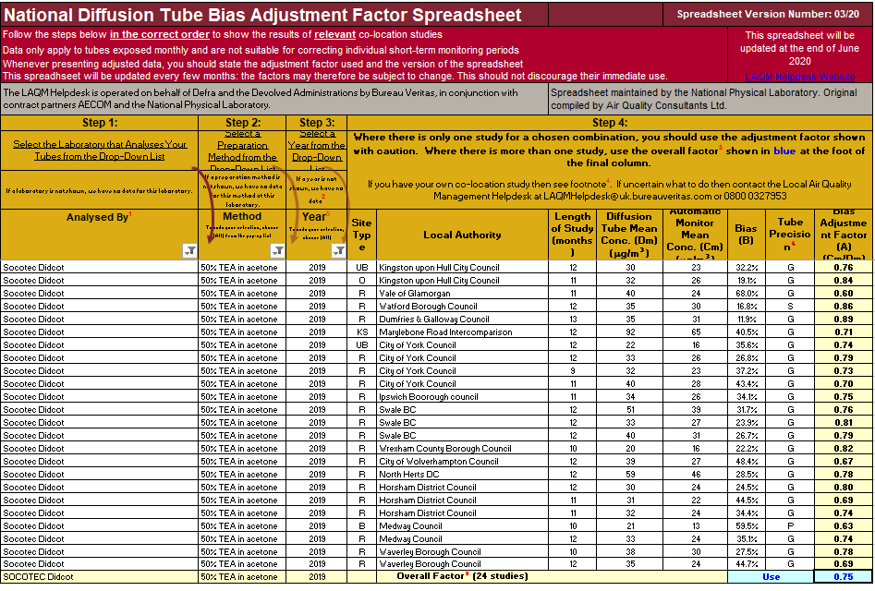

Factor from Local Co-location Studies
Co-located NO₂ diffusion tubes are installed at the automatic monitoring site TH51/52/53 - Boundary Road, Ramsgate (co-located with ZH4).
However, the data capture was too low in 2019 to produce a local bias adjustment factor, therefore the national factor was used.
Short to Long Term Adjustment
For diffusion tube monitoring where data capture for the year was less than 75%, data have been annualised using a ratio factor derived from measured NO₂ concentrations at AURN background automatic monitoring stations located at Canterbury, Southern-on-Sea, Rochester Stoke and St Osyth. In 2019, these stations had data capture of over 90%. The annual mean and associated period mean concentrations for each of the monitoring stations are outlined in Table C.2 below. The factor applied has then been determined from the average of the ratios from all four monitoring stations.
Details of the annualisation factor used for diffusion tubes TH32 and TH81 are presented in Table C.3.
Table C.3: Determination of Annualisation Factors
Diffusion Tube ID |  | Canterbury | Southern-on-Sea | Rochester Stoke | St Osyth
TH32 | Annual Mean (µg/m³) | 12.1 | 17.9 | 12.5 | 13.1
 | Period Mean (µg/m³) | 12.7 | 18.2 | 12.4 | 13.5
 | Ratio | 0.956 | 0.981 | 1.009 | 0.967
 | Annualisation Factor | 0.978
TH81 | Annual Mean (µg/m³) | 12.1 | 17.9 | 12.5 | 13.1
 | Period Mean (µg/m³) | 12.0 | 17.2 | 12.2 | 12.0
 | Ratio | 1.009 | 1.039 | 1.024 | 1.089
 | Annualisation Factor | 1.040

Distance Adjustment
None of the tubes needed distance correcting (only 1 tube was within 10% of the objective, but already located on the façade of a residential property).
QA/QC of Automatic Monitoring
The QA/QC procedures for the sites are those of the Kent and Medway Air Quality Monitoring Network (K&MAQMN). The K&MAQMN procedures are equivalent to the UK Automatic Urban and Rural Network (AURN) procedures, with the exception of the following:
- Calibration of NOx analysers with NO gas only (AURN also use NO₂);
- Data checks are done once daily and downloads are done twice daily (AURN are hourly); and
- Independent audits of the stations are undertaken annually (AURN are 6 monthly). Ricardo AEA ratify the data for both the AURN and K&MAQMN sites.
QA/QC of Diffusion Tube Monitoring
Socotec Didcot is a UKAS accredited laboratory and participates in the new AIR PT Scheme (a continuation of the Workplace Analysis Scheme for Proficiency (WASP)) for NO₂ tube analysis and the Annual Field Inter-Comparison Exercise. These provide strict performance criteria for participating laboratories to meet, thereby ensuring NO₂ concentrations reported are of a high caliber. The lab follows the procedures set out in the Harmonisation Practical Guidance. In the latest available results, AIR-PT AR031, AIR-PT ARO33 and AIR-PT ARO34 Socotec Didcot have scored 100% and AIR-PT ARO30 it scored 87.5%. The percentage score reflects the results deemed to be satisfactory based upon the z-score of <+/- 2. Based on 24 studies from Socotec Didcot utilizing the 50% TEA, all local Authority co-location studies in 2019 were rated as ‘good’ precision (tubes are considered to have “good” precision where the coefficient of variation of duplicate or triplicate diffusion tubes for eight or more periods during the year is less than 20%), with the exception of one which was rated as ‘poor’, and one which used a single diffusion tube monitoring site.

Appendix D: Maps of Monitoring Locations and AQMAs

Figure D.1 Thanet Urban AQMA
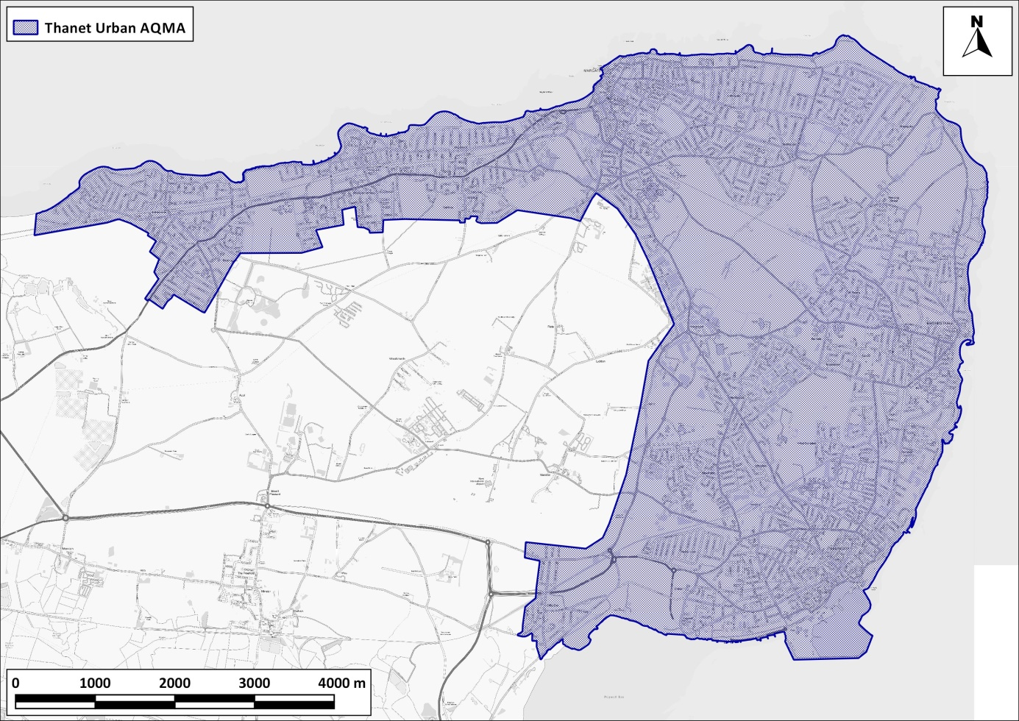

Contains Ordnance Survey data © Crown copyright and database right 2020. Ordnance Survey licence number 100046099. Additional data sourced from third parties, including public sector information licensed under the Open Government Licence v1.0.

Figure D.2 Overview of Thanet Monitoring Locations
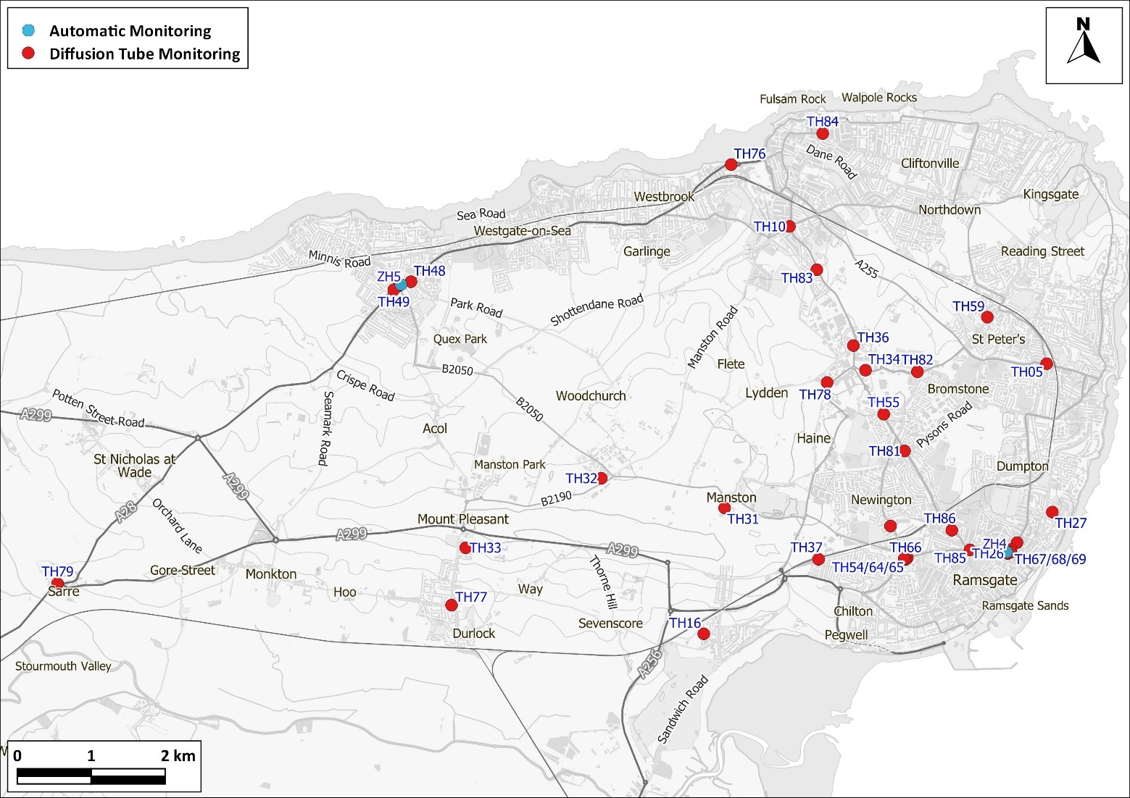

Contains Ordnance Survey data © Crown copyright and database right 2020. Ordnance Survey licence number 100046099. Additional data sourced from third parties, including public sector information licensed under the Open Government Licence v1.0.

Figure D.3 Monitoring Locations in Birchington
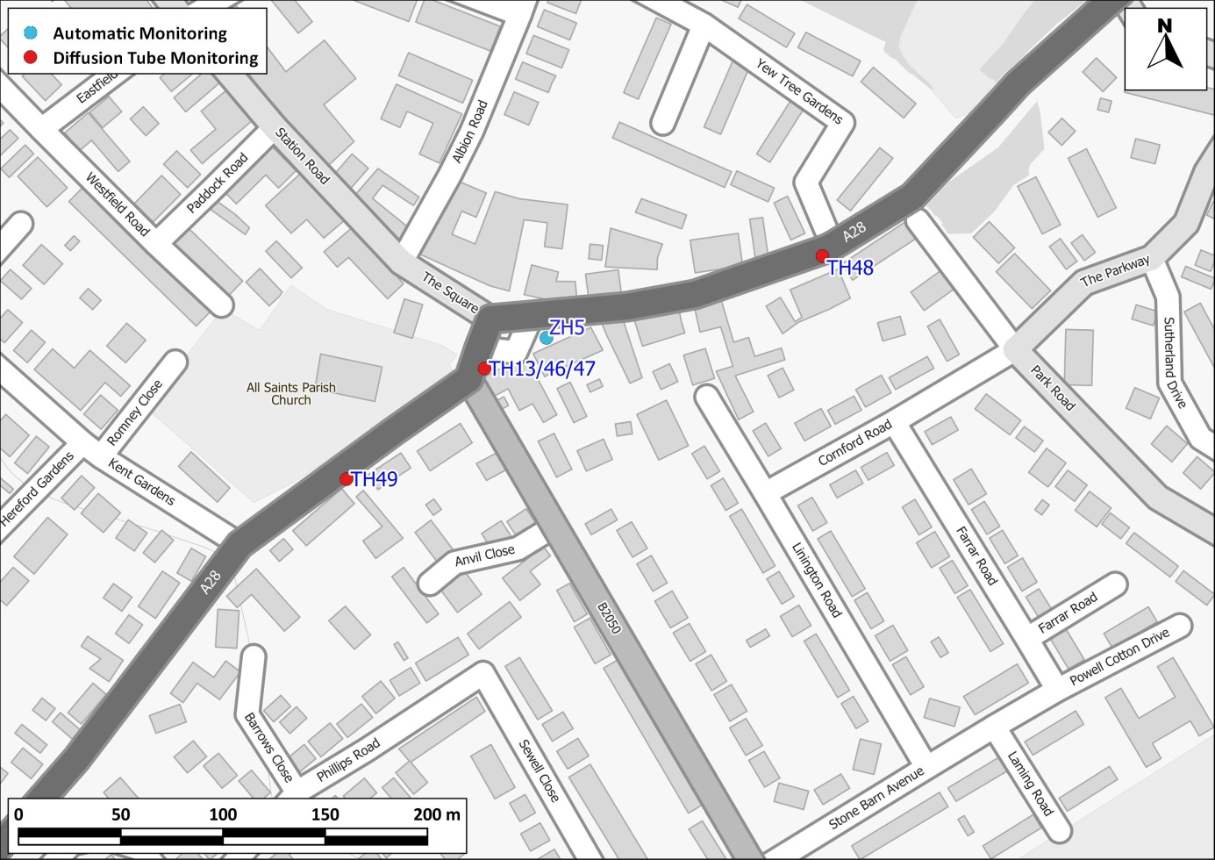

Contains Ordnance Survey data © Crown copyright and database right 2020. Ordnance Survey licence number 100046099. Additional data sourced from third parties, including public sector information licensed under the Open Government Licence v1.0.

Figure D.4 Monitoring Locations in Minster
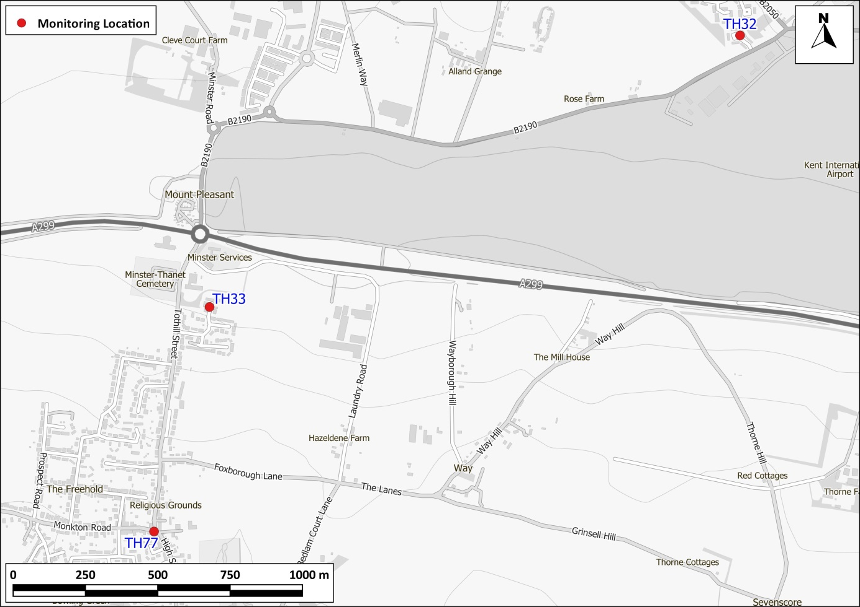
Contains Ordnance Survey data © Crown copyright and database right 2020. Ordnance Survey licence number 100046099. Additional data sourced from third parties, including public sector information licensed under the Open Government Licence v1.0.

Figure D.5 Monitoring Locations in Cliffsend, Ramsgate
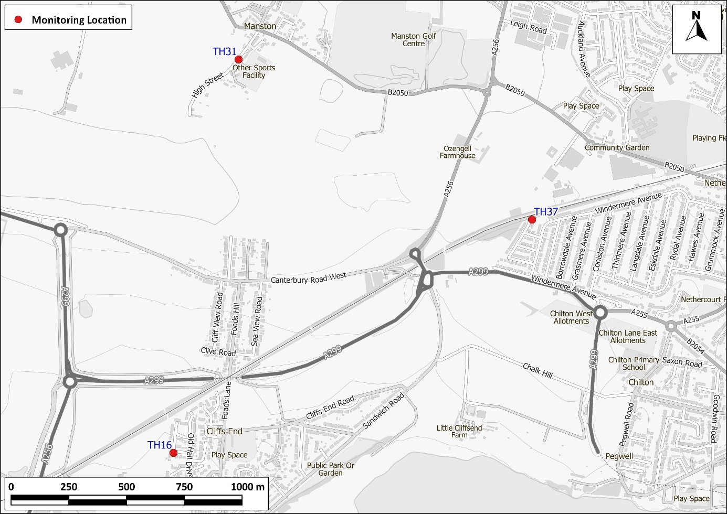

Contains Ordnance Survey data © Crown copyright and database right 2020. Ordnance Survey licence number 100046099. Additional data sourced from third parties, including public sector information licensed under the Open Government Licence v1.0.

Figure D.6 Monitoring Locations in Westwood
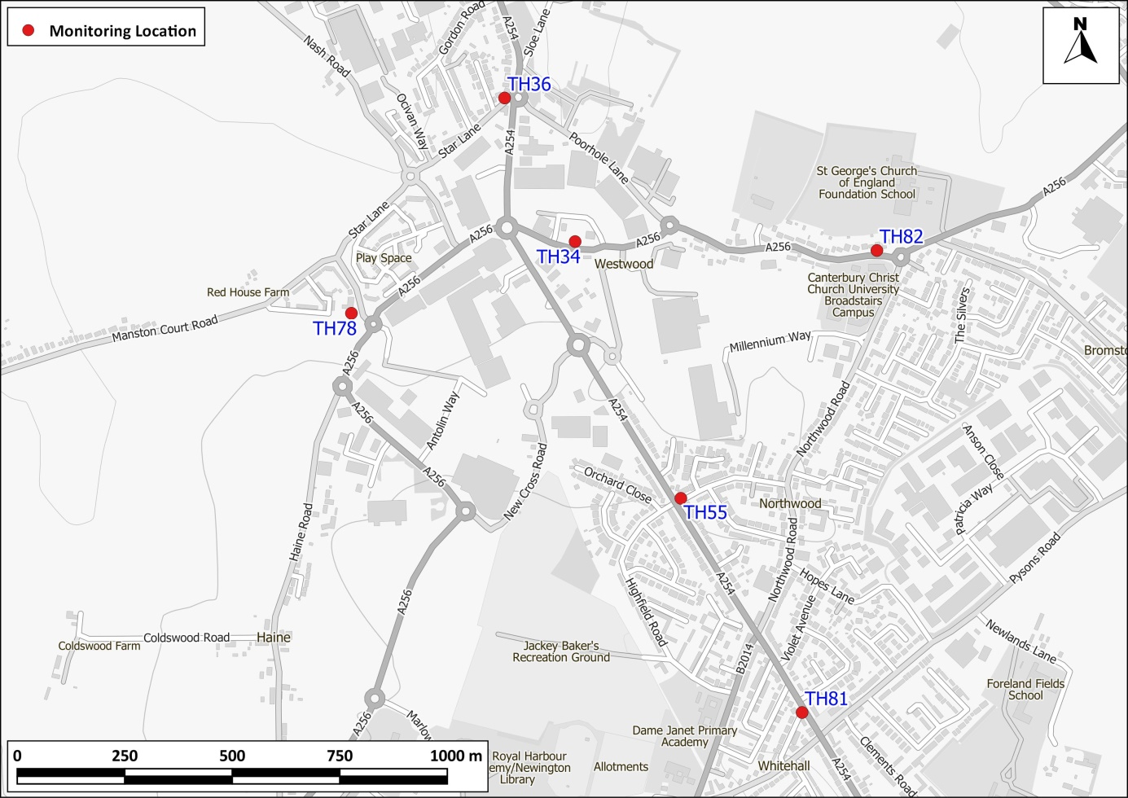

Contains Ordnance Survey data © Crown copyright and database right 2020. Ordnance Survey licence number 100046099. Additional data sourced from third parties, including public sector information licensed under the Open Government Licence v1.0.

Figure D.7 Monitoring Locations in St Peters, Broadstairs
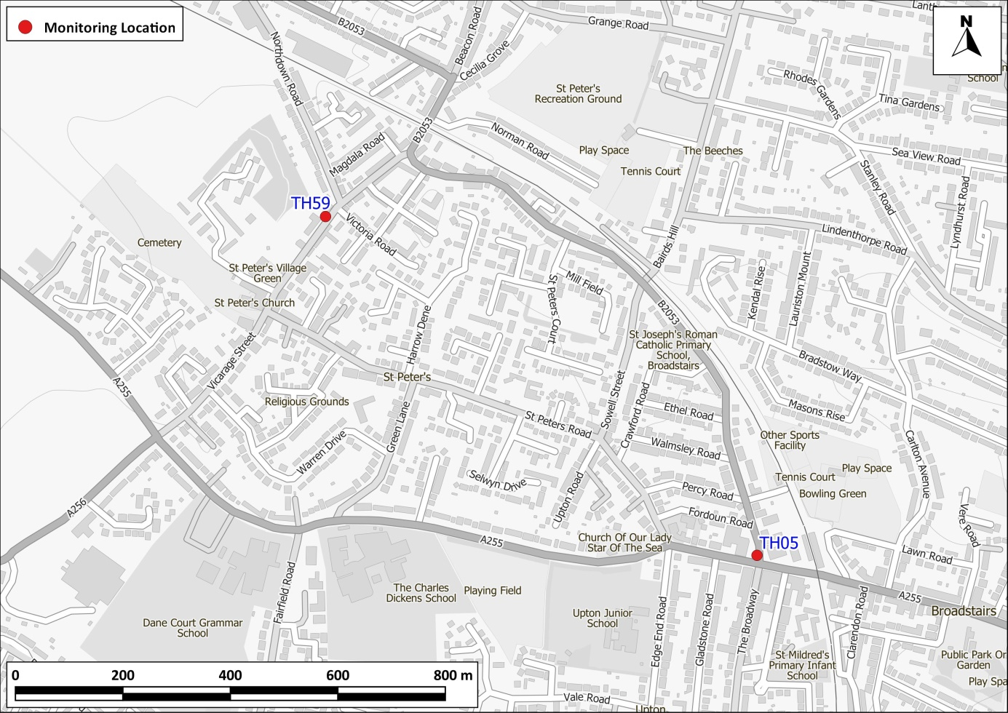
Contains Ordnance Survey data © Crown copyright and database right 2020. Ordnance Survey licence number 100046099. Additional data sourced from third parties, including public sector information licensed under the Open Government Licence v1.0.

Figure D.8 Monitoring Locations in Margate
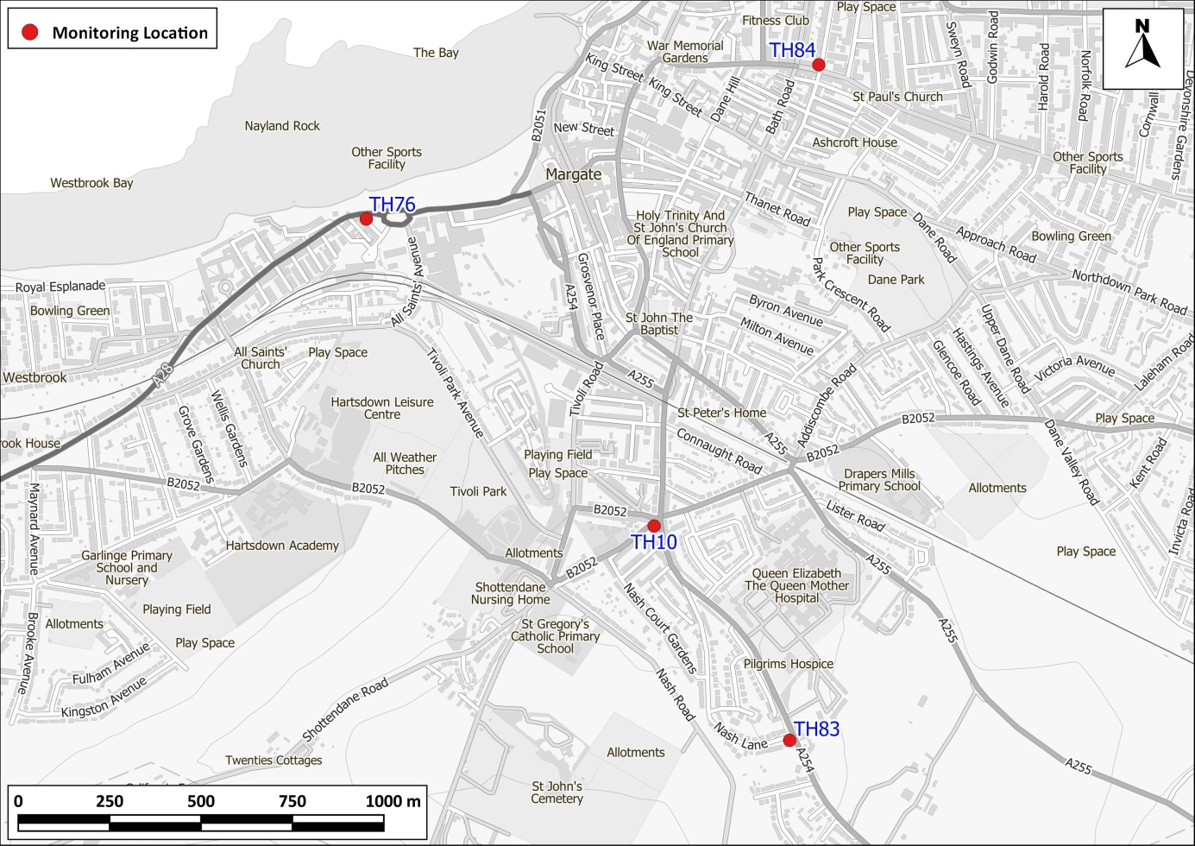
Contains Ordnance Survey data © Crown copyright and database right 2020. Ordnance Survey licence number 100046099. Additional data sourced from third parties, including public sector information licensed under the Open Government Licence v1.0.

Figure D.9 Monitoring Locations in Ramsgate
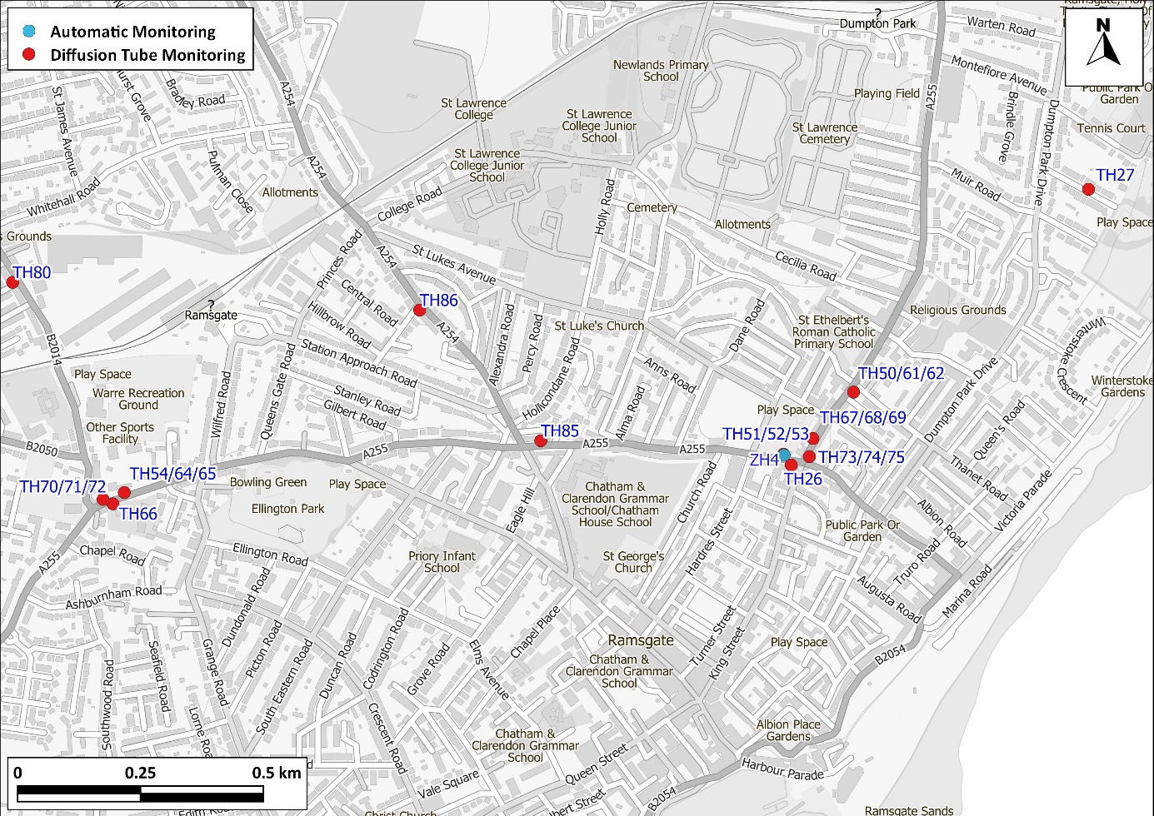

Contains Ordnance Survey data © Crown copyright and database right 2020. Ordnance Survey licence number 100046099. Additional data sourced from third parties, including public sector information licensed under the Open Government Licence v1.0.

Figure D.10 Monitoring Locations in Sarre
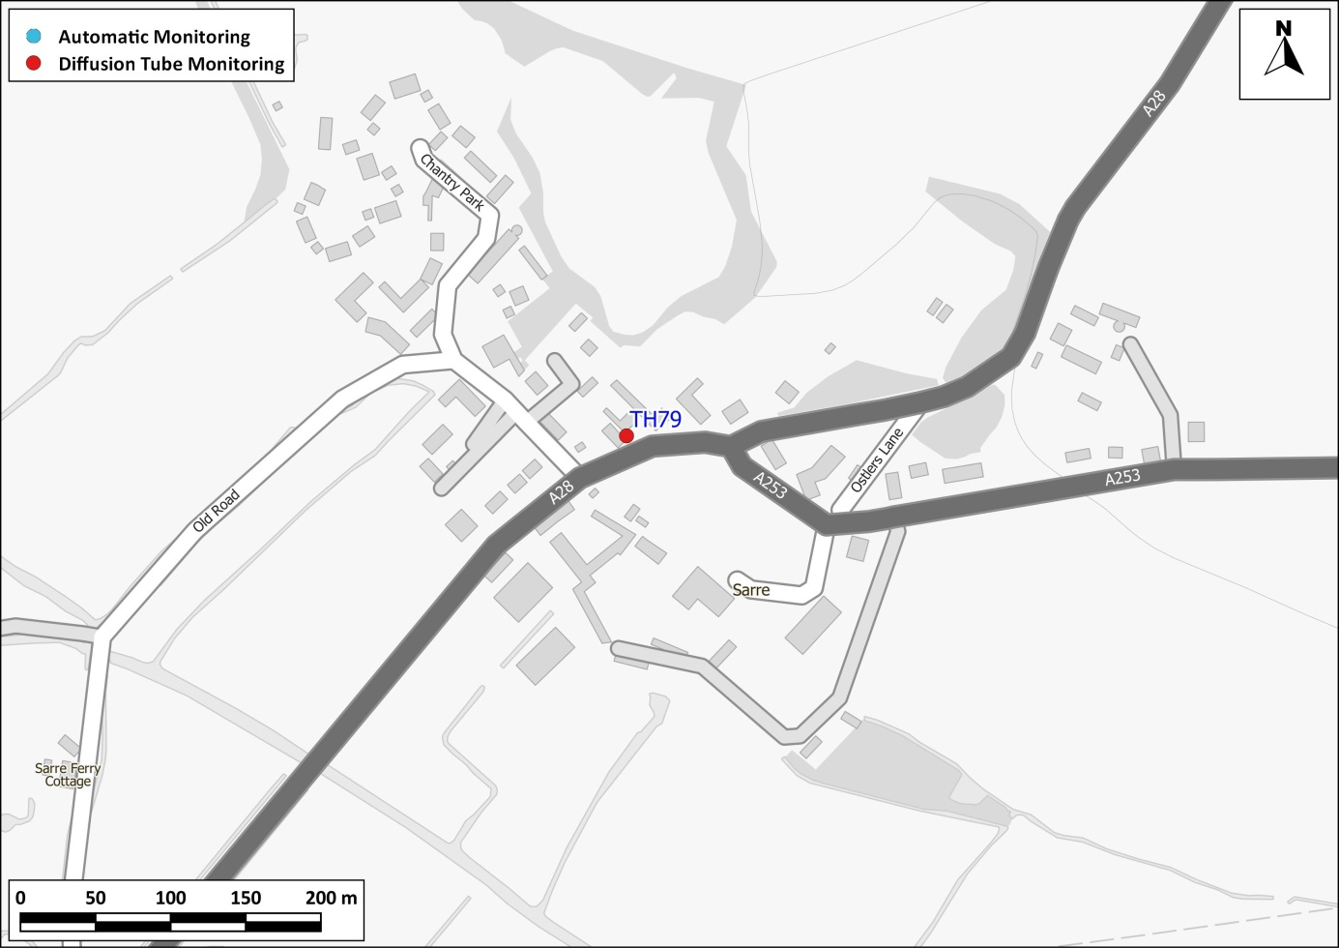

Contains Ordnance Survey data © Crown copyright and database right 2020. Ordnance Survey licence number 100046099. Additional data sourced from third parties, including public sector information licensed under the Open Government Licence v1.0.

Appendix E: Summary of Air Quality Objectives in England
Table E.1 – Air Quality Objectives in England
Pollutant | Air Quality Objective
 | Concentration | Measured as
Nitrogen Dioxide (NO₂) | 200 µg/m³ not to be exceeded more than 18 times a year | 1-hour mean
 | 40 µg/m³ | Annual mean
Particulate Matter (PM₁₀) | 50 µg/m³, not to be exceeded more than 35 times a year | 24-hour mean
 | 40 µg/m³ | Annual mean
Sulphur Dioxide (SO₂) | 350 µg/m³, not to be exceeded more than 24 times a year | 1-hour mean
 | 125 µg/m³, not to be exceeded more than 3 times a year | 24-hour mean
 | 266 µg/m³, not to be exceeded more than 35 times a year | 15-minute mean

Glossary of Terms
Abbreviation | Description
AQAP | Air Quality Action Plan - A detailed description of measures, outcomes, achievement dates and implementation methods, showing how the local authority intends to achieve air quality limit values’
AQMA | Air Quality Management Area – An area where air pollutant concentrations exceed / are likely to exceed the relevant air quality objectives. AQMAs are declared for specific pollutants and objectives
ASR | Air quality Annual Status Report
Defra | Department for Environment, Food and Rural Affairs
DMRB | Design Manual for Roads and Bridges – Air quality screening tool produced by Highways England
EU | European Union
FDMS | Filter Dynamics Measurement System
K&MAQMN | Kent and Medway Air Quality Monitoring Network
K&MAQP | Thanet District council is part of the Kent and Medway Air Quality Partnership
LAQM | Local Air Quality Management
NO₂ | Nitrogen Dioxide
NO_{x} | Nitrogen Oxides
PM₁₀ | Airborne particulate matter with an aerodynamic diameter of 10µm (micrometres or microns) or less
PM_{2.5} | Airborne particulate matter with an aerodynamic diameter of 2.5µm or less
QA/QC | Quality Assurance and Quality Control
SO₂ | Sulphur Dioxide

References
- Local Air Quality Management Technical Guidance LAQM.TG16 Published by Defra in partnership with the Scottish Government, Welsh Assembly Government and Department of the Environment Northern Ireland.
- Local Air Quality Management Policy Guidance LAQM.PG16. Published by Defra
- Air Quality Technical Planning Guidance 2016. Published by Thanet District Council
- Thanet District Council 2018 Updating and Screening Assessment.
- Thanet District Council Air Quality Action Plan 2013. Published by Thanet District Council.
- National Diffusion Tube Bias Adjustment Spreadsheet, version 06/19 published in June 2019.
- https://laqm.defra.gov.uk/assets/laqmno2performancedatauptofebruary2019v1.pdf
- Environment Act (1995). Published by HMSO.

Environmental equity, air quality, socioeconomic status, and respiratory health, 2010
Air quality and social deprivation in the UK: an environmental inequalities analysis, 2006
Defra. Abatement cost guidance for valuing changes in air quality, May 2013 ⁴ Kent Public Health Observatory, Air Quality, April 2018
Low data capture (42.3%) for Ramsgate monitoring station in 2019.
The units are in microgrammes of pollutant per cubic metre of air (µg/m³).

